TEAM: MV Bees

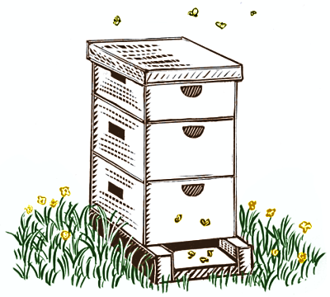
ALL ABOUT THE HIVE!

RSU 10 (MV Bee Academy) needs a way to Support students struggling with ACES to access and engage in education, improve attendance, foster and maintain resilience skills, and promote positive behaviors.

What is the problem to be solved?
Students have trauma ( ACES ) – Behavior issues
Access / engagement in education – trauma barrier
Keep fostering resilience skills
Chronic absenteeism
Transitioning from 3 schools to 1 school – Glue
Experiences in nature / Hands on activates
Skill building –
Help cope with ACES
Focus / Succeed
Build resilience –
Improving attendance –
New Principle added to the MV Bees
Transitioning from 3 schools to 1 school – Glue
Transitioning 3 unique environments in to one, community building challenges, culture shift, paint a picture of the environmental differences – new school opportunities, grade levels. SCALE AND SUSTAINABILITY

Community support and buy in – WMBA
Impact of community connection on engagement

How do you know it’s a problem?
Students have trauma ( ACES ) – Behavior issues
PBIS - SWIS data (ODR’s), # of social workers / supports full capacity - waiting lists, % of students accessing counseling, # of students accessing behavior interventions, % free and reduced lunch
Free and Reduced Lunch Numbers from October 2021: MVMS - 81%; RES - 73%; MES - 75%
Access / engagement in education – Time sampling, relationship building – harder (swis data, removal of classroom, boredom, wandering halls, preoccupied by things going on at home, emotional needs not being taken care of, distracted by worries, anxiety, hunger), % of students accessing social worker, 504 sky rocked,
Keep fostering resilience skills – PBIS survey
Chronic absenteeism
Attendance data (powerschool), students coming in late, catching up after being out

Problem / Challenge:

Why?

Why?

Why?

Why?

Why?

What data will you / have you consulted to verify the problem exists? Cheryl’s BEST article

What data will be / did you use to determine the students to be targeted by the innovation?
ACES -

